PRESS RELEASE
01/31/20 For Immediate Release

Color Marketing Group 2020 Events

Color Marketing Group announces color design and forecasting events for 2020.

“We have an amazing line-up this year of color forecasting Workshops and color Conferences you and your design team won’t want to miss! Collaborate with color design professionals on our multi-industry global 2022+ World Color Forecast™ and receive color direction information you can apply today,” says Sandra Sampson, VP PR and Communications for Color Marketing Group.

CMG 2020 Events
As of 013120
CMG Events Calendar https://colormarketing.org/upcoming-events/

ChromaZone® Color Forecasting Workshops
At the very heart of all CMG events is the Color Forecasting process where the world’s leading color and design influencers share, discuss and explore color directions and influences. You will be on the cutting edge of color forecasting, and you’ll bring these insights back with you to shape and validate discussions and decisions on color directions for your industry, product or service. Each ChromaZone® Workshop is a collaboration of minds; a joint effort to understand and interpret what is happening in the world around us and how this will influence color. Participants identify 16 colors, along with the influences and inspirations that define them, that they believe will trend in 2022.

Who Should Attend a ChromaZone®?
Global manufacturers, brands, and marketers understand the importance of color marketing to their bottom line. Your company will benefit from creating research fueled and validated products in colors that sell. As a project manager, product developer, designer, manufacturer, CMF specialist, color specifier, and anyone who works with color for products, you won’t want to miss the important color discussions at the next ChromaZone®, Conference and International Summit. Participants are industry icons, leading brands, visionaries, forward-thinkers and the next generation… united by their passion for color and their need to know WHAT’S NEXT?
You do NOT need to be a member of CMG to participate – ChromaZone® events are open to current, former, and Non-CMG members. We are also inviting members of related professional organizations, education and media. If you are interested in learning more about becoming part of Color Marketing Group® please visit our Membership page to learn more or contact the office.

The Benefits of Attending a ChromaZone®
By attending this exciting Workshop you will come away with first-hand information about colors emerging in 2022+ ready for application into your product development workflow.

Each ChromaZone® produces a digital color forecast and a written report on the color stories that support that forecast. The final product is distributed to all participants.

How to Prepare for a ChromaZone®
Each participant is asked to plan and prepare in advance; to research; identify influences, trends and drivers; and to bring samples and color stories to support their findings. This research is then shared, discussed, and narrowed down to common themes, trends and ideas.

Pre-preparation is required by completing the Color ChromaZone® Worksheet WHICH WILL BE E-MAILED TO YOU UPON CONFIRMATION OF YOUR REGISTRATION. The Worksheet gives you a good indication of what you are expected to prepare, think about and bring to the Workshop. In advance of the Workshop you must review the Worksheet, gather information and samples to support your findings, and bring samples and stories to share at the Workshop discussion table. Please bring digital, royalty-free images (both on flash drive and printed) to be used for presenting the Color Stories in the final Report. Copyright-free visuals are essential. Please digitally insert AND attach your 12 to 16 2022+ ChromaZone Forecast swatches in Pantone TPX, NCS, or RAL, Other color swatches may be used on the worksheet (i.e. paint chips). They will be matched to the closest NCS notation during the workshop. You are welcome to bring a PowerPoint or digital presentation, but it is not mandatory. You must bring your own computer to display your presentation.

CMG 2020 ChromaZone® Santa Ana, CA
Country: U.S.A
Date: Friday May 15, 2020, 9:00 a.m. – 5:30 p.m.
Host: Behr Paint
Location: 1801 E. St Andrews Place, Santa Ana CA 92706

CMG 2020, Bonn, Germany
Country: Germany
Dates: March 10, 2020
Location: RAL gemeinnützige GmbH, Fränkische Straße 7 · 53229 Bonn · Germany
Host: RAL Colours

CMG 2020 ChromaZone® Chattanooga
Country: USA
Dates: Wednesday March 11, 2020, 9:00 a.m. – 5:00 p.m.
Host: Techmer PM
Location: The Chattanoogan, 1201 Broad Street, Chattanooga TN 37402

CMG 2020 ChromaZone® Milan
Country: Italy
Dates: Monday, April 20, 20202, 9:00 a.m. – 5:00 p.m.
Host: Clariant Plastics & Coatings (Italia) S.p.A
Location: Via Bergamo 77, 23807 Merate (LC) Italy

CMG 2020 ChromaZone® Minneapolis
Country: USA
Dates: Tuesday July 14th, 2020, 9:00 a.m. – 5:00 p.m.
Host: The Sherwin-Williams Company
Location: 1008 1/2 South 3rd St, Minneapolis MN 55415

CMG 2020 ChromaZone® Chicago, Illinois
Country: U.S.A
Date: Wednesday, June 10, 2020, 9:00 a.m. – 5:30 p.m.
Host: Daltile
Location: 316 West Hubbard Street, Chicago IL 60654

CMG 2020 ChromaZone® San Francisco, CA
Country: U.S.A
Date: Friday April 24th, 2020, 9:00 a.m. – 5:30 p.m.
Host: Kelly-Moore Color Studio San Francisco. (Located in the heart of the Mission District, there is a free parking lot and Muni bus stop (49 Van Ness) which stops at Van Ness and 16th Street, and a BART (Bay Area Rapid Transit) stop one block away. Both of these modes run between Market Street (downtown), and the Mission district.)
Location: 565 South Van Ness Avenue, San Francisco 94110

CMG 2020 ChromaZone® Cleveland, Ohio
Country: U.S.A
Date: Thursday, 2020, 9:00 a.m. – 5:00 p.m.
Host: Tarkett
Location: 30000 Aurora Road, Solon OH 44139

CMG 2020 ChromaZone® Toronto, Ontario
Country: Canada
Dates: Thursday May 7, 2020, 9:00 a.m. – 5:30 p.m.
Host: Toronto International Design Centre
Location: 6900 Airport Road, Mississauga ON L4V 1E8

CMG 2020 ChromaZone® Vancouver
Country: Canada
Dates: Friday, May 8, 2020, 9:00 a.m. – 5:00 p.m.
Hosts: Centura Tile and American Biltrite
Location: Centura Tile, 4616 Canada Way, Burnaby, BC V5K 1K5

CMG 2020 ChromaZone® Davidson, North Carolina
Country: USA
Dates: Thursday, May 21, 2020, 9:00 a.m. – 5:00 p.m.
Location: 3A Composites, 721 Jetton Street, Suite 325, Davidson NC 28036

CMG 2020 ChromaZone® Montréal
Country: Canada
Language: This Workshop will be conducted in French
Dates: Friday, May 29th, 2020, 9:00 a.m. – 5:00 p.m.
Host: Centura Tile & American Biltrite
Location: Centura Tile, 5885 Chemin de la Côte de Liesse, Ville St-Laurent, QC H4T 1C3

CMG 2020 Conferences

CMG 2020 European Conference, Stockholm, Sweden
Country: Sweden
Dates: Wednesday, May 13th – Friday May 15th, 2020
Location: Clarion Hotel Amaranten

2022+ European Forecast
We recently revealed the 2021+ European Forecast during our 2019 International Summit – now we begin to forecast color directions for 2022 and beyond and YOU can be part of that conversation. Our Conference Workshops offer a chance to explore and recognize subtle nuances in color, to envision which palettes and color combinations will best attract, inspire, and inform, and to explore the global influences and drivers that affect color directions.

At the very heart of all CMG Conferences is the Color Forecasting process where the world’s leading color and design influencers share, discuss and explore color directions. You will be on the cutting edge of color forecasting, and you’ll bring these insights back with you to shape and validate discussions and decisions on color directions for your industry, product, or service. CMG’s Color Forecasting process is a collaboration of minds; a joint effort to understand and interpret what is happening in the world around us and how this will influence color. The final result? A 16-color Directional Forecast that is distributed electronically with a report identifying the trends and influences affecting color directions. The Color Forecast shows notations in all the major color systems including Pantone, NCS, RAL, RGB and L*a*b*.

Who Should Attend?
Global manufacturers, brands, and marketers understand the importance of color marketing to their bottom line. Your company will benefit from creating research fueled and validated products in colors that sell. As a project manager, product developer, designer, manufacturer, CMF specialist, color specifier, and anyone who works with color for products you won’t want to miss the important color discussions.
You do NOT need to be a member of CMG to participate in this Conference. If you are interested in learning more about becoming part of Color Marketing Group please visit our Membership page to learn more or contact the office.

The Benefits of Attending
At this Conference, you’ll have access to amazing events and fascinating speakers, along with plenty of opportunities to share and collaborate with other professionals across all industries—people who, like you, are constantly searching for inspiration, for what’s next in color.

• Join the latest color conversations helping you to succeed in your field and helping your company to achieve continued growth.

• You’ll network with individuals outside your specific industry, expanding your horizons and opening new areas for exploration.

• We provide an open-discussion atmosphere that will allow you to mix, mingle, and come away with lasting relationships and connections. The friends you make will form your “tribe” for years to come, and their energy and insight will prove invaluable.

• You’ll leave with newfound color revelations that will keep you, your company, and your clients well-versed in all things color.

Location
Clarion Hotel Amaranten, Stockholm, Sweden

CMG 2020 Asia Pacific Conference, Shanghai China
Country: China
Dates: July 23rd and 24th
Location: Sofitel Hyland Shanghai, 505 Nanjing Road East, 200001 Shanghai, China.

2022+ Asia Pacific Forecast
At the very heart of all CMG Conferences is the Color Forecasting process where the world’s leading color and design influencers share, discuss and explore color directions. You will be on the cutting edge of color forecasting, and you’ll bring these insights back with you to shape and validate discussions and decisions on color directions for your industry, product or service. CMG’s Color Forecasting process is a collaboration of minds; a joint effort to understand and interpret what is happening in the world around us and how this will influence color. The final result – a 16-color Directional Forecast that is distributed electronically with a report identifying the trends and influences affecting color directions. The Color Forecast shows notations in all the major color systems including Pantone, NCS, RAL, RGB and L*a*b*.

Who Should Attend?
Global manufacturers, brands, and marketers understand the importance of color marketing to their bottom line. Your company will benefit from creating research fueled and validated products in colors that sell. As a project manager, product developer, designer, manufacturer, CMF specialist, color specifier, and anyone who works with color for products you won’t want to miss the important color discussions.
You do NOT need to be a member of CMG to participate in this Conference. If you are interested in learning more about becoming part of Color Marketing Group please visit our Membership page to learn more or contact the office.

The Benefits of Attending
At this Conference, you’ll have access to amazing events and fascinating speakers, along with plenty of opportunities to share and collaborate with other professionals across all industries—people who, like you, are constantly searching for inspiration, for what’s next in color.

• Join the latest color conversations helping you to succeed in your field and helping your company to achieve continued growth.

• You’ll network with individuals outside your specific industry, expanding your horizons and opening new areas for exploration.

• We provide an open-discussion atmosphere that will allow you to mix, mingle, and come away with lasting relationships and connections. The friends you make will form your “tribe” for years to come, and their energy and insight will prove invaluable.

• You’ll leave with newfound color revelations that will keep you, your company, and your clients well-versed in all things color.

Location
Sofitel Hyland Shanghai.

CMG International Summit
Country: North America
Dates: November 19 to 21, 2020
Location: Austin, Texas
Details: More details to come. Please check https://colormarketing.org/upcoming-events/

CMG Blog https://colormarketing.org/blog/
Visit our blog for the most up-to-date information and sign up for our bi-weekly Color Connection newsletter.

COLOR MARKETING GROUP is accepting Guest Speaker abstracts for our 2020 events:
European Conference
Stockholm, Sweden
May 13 to 15, 2020

International Summit
Austin, Texas
November 19 to 21, 2020

This is your opportunity to present to CMG multi-industry, global color design professionals!

Engage with CMG members and share your innovative and immersive ideas and work in the business of color.

CMG attendees are global color design experts from a variety of industries who seek new and exciting content, and innovative and immersive ideas from experts in their field. Guest Speaker topics should be thought-leading and inspiring, addressing topics which appeal to the color/design community such as:

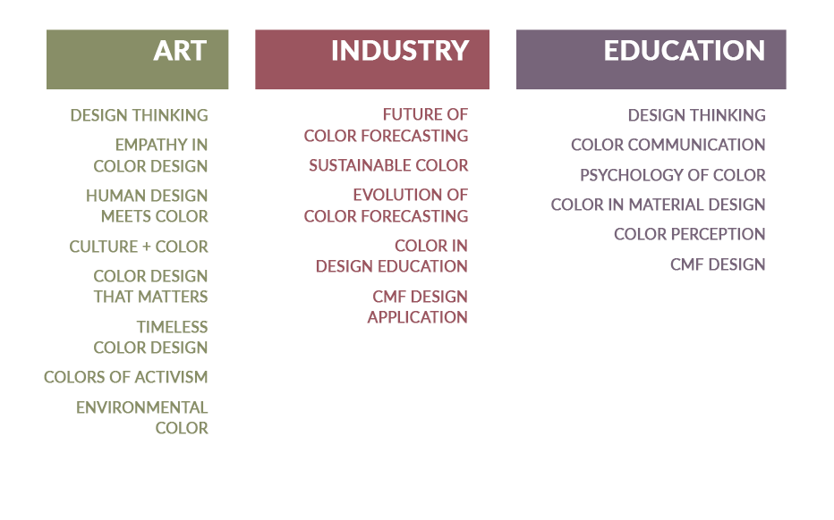
If you would like the opportunity to be a Guest Speaker, please submit your presentation Abstract and Call For Speaker Form to sgriffis@colormarketing.org. Submissions will be reviewed by the 2020 Event Committees and you will receive notification of the status of your submission by the end of March.

The deadline for submissions is Friday, February 21st.
We very much appreciate your interest and welcome your submission, but regrettably, we cannot accept all speaking submissions.

https://colormarketing.org/2020/01/28/call-for-speakers/

New Media Page
For breaking press releases about Color Marketing Group please visit our Media Page.
https://colormarketing.org/media-page/

CONTACT INFORMATION
Color Marketing Group®
Sharon Griffis
Executive Director
703.329.8500
Contact via Email
colormarketing.org

Sandy Sampson
VP Communications & PR
805.216.8631
Contact via Email

JOIN US
Visit colormarketing.org to learn more.
A full palette of knowledge.

ABOUT COLOR MARKETING GROUP®
Color Marketing Group®, founded in 1962, is a not-for-profit international association of color design experts who forecast color directions and is a forum for the exchange of all aspects color. Members represent a broad spectrum of designers, marketers, color scientists, consultants, educators, and artists. Color forecasting events are held throughout the world and the results from these events become part of the global World Color Forecast™ revealed at the annual International Summit.

MEDIA
Members of the media are invited to attend ChromaZone® Color Forecasting Workshops to write articles about the process, methodology, attendees, and to hint at overarching themes of discussions without disclosing the color directions. To arrange media attendance, please contact CMG below.

